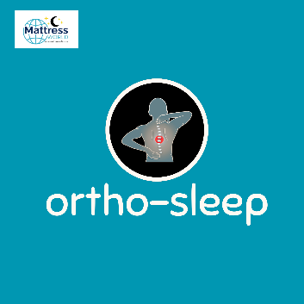
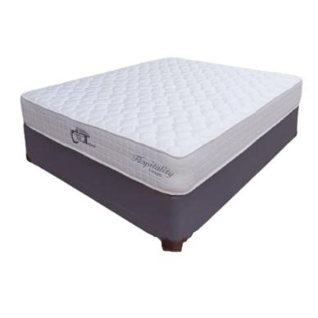

Model : Hospitality-Foam Bed Set
Supplier/Manufacturer : Mattress World
Range : Ortho Sleep Range – All Ortho Sleep Range Mattresses are Orthopedic Design. Made stronger to help improve posture, better quality than average mattresses and keep their shape and feel for a longer period of time. Great quality and good for back support.
Features :
- Hospitality Grade Quality
- Heavy Duty Support Foam Core
- High Density Orthopedic Comfort Foam
- Turnable Design
- Multi Layered Foam
- 120kg Per Person Per Side
- 1 Year Guarantee
- 15 Year Warranty
- Firm Feel
Prices – Bed Set :
- Single Bed Set – R3999
- Three Quarter Bed Set – R4499
- Double Bed Set – R5499
- Queen Bed Set – R5499
- King Bed Set – R7499
- Super King Bed Set - R9999
Prices – Mattress Only :
- Single Mattress Only – R3499
- Three Quarter Mattress Only – R3999
- Double Mattress Only – R4999
- Queen Mattress Only – R4999
- King Mattress Only – R6499
- Super King Mattress Only - R7999
Prices - Extra Length Bed Set :
- Single Extra Length Bed Set – R4799
- Three Quarter Extra Length Bed Set – R5399
- Double Extra Length Bed Set – R6599
- Queen Extra Length Bed Set – R6599
- King Extra Length Bed Set – R8999
Prices - Extra Length Mattress Only :
- Single Extra Length Mattress Only – R4199
- Three Quarter Extra Length Mattress Only – R4799
- Double Extra Length Mattress Only – R5999
- Queen Extra Length Mattress Only – R5999
- King Extra Length Mattress Only – R7799

